55 inch LCD Monitor (4K)
Model: ZAX-YJ55LED/4K/RT


Features:
- With 3D Deinterlace Decoding technology, the image is smooth;
- Support 3D digital comb filter and MPEG digital image noise reduction with sharper images;
- Support HDMI2.0 4K input , and HDMI 2.0 support max resolution up to 3840*2160@60Hz;
- 5ms fast response time, no trailing;
- Tempered glass, vandal proof, built-in speaker;
- Low consumption, Energy- saving, working life over 50,000H;
- The metal glaze paint housing, no radiation, durable;
- No need CPU or operating system support, no system crashes, no virus infection.

Specification:
Screen Size | 55inch
Aspect Ratio | 16:9
Visible Size | 1210mm(H)×676.5mm(V)
Panel | TFT LED
Max Resolution | 3840*2160
Display Color | 1.07G
Brightness | 500cd/㎡
Contrast | 5000：1
Viewing Angle | 178°(H)/178°(V)
Response Time | 5ms
Field Frequency | 50-75Hz
Lamp Life | ＞50,000 H
HDMI Input | 2CH HDMI2.0 Input
USB Input | 1CH USB Input
Inbuilt Speaker | 2x8Ω 10W
Color System | PAL/NTSC
Compatible HD/SD and HDMI Input | 480i, 480p, 576i, 576p, 720p, 1080i, 1080p, 4Kx2K@60Hz
3D Deinterlace Decoding | Support
3D Comb filter | Support
MPEG Noise Reduction | Support
Language Menu | Chinese /English
Voltage | AC 100V～240V，50/60Hz
Watt | 260W
Standby Watt | ＜1W
Heat Dissipation System | Ultra-quiet thermostat -Cooling Fan
Housing | Metal glaze paint
Dimension | 1250.8mm*721.7mm*68mm (for reference)
Installation | Wall-Mounted/mobile standing
Accessory | Wall- bracket / Power Supply, Remote Controller, Manual , Warranty Card

Structure:
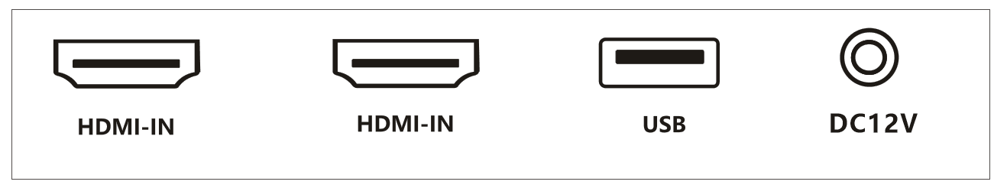

Для связи с нами:

ТОО "RSP Music"
РК, 050000 г. Алматы, БЦ Каспий, ул. А.Шарипова 90, оф. 215
(Вход со стороны Досмухамедова 89)

Тел.моб: +7 701 577 67 70
e-mail: mix@redsp.kz

